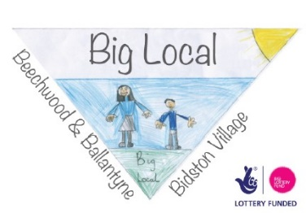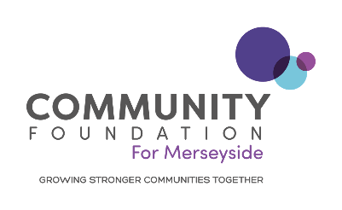
Award Process
Big Local Young Person’s Ideas Fund has been developed for young people that live in Beechwood, Ballantyne or Bidston Village Big Local area to apply for funding for a project of their choice.
Young Person’s Fund

Applicants must meet the following criteria:

- Organisations must be a Constituted/Community Group and have their own bank account.
- The maximum grant available is £500
- The project must benefit Big Local residents
- Organisations must provide copies of the relevant supporting information and policies upon request (see application form)
- Organisations must include the Big Local logo on marketing material and on any project promotions e.g. Social Media.
- Organisations must provide adequate monitoring and evaluation records including evidence of expenditure and the impact the project has had on our neighbourhoods.
- Core-running costs or political campaigns will not be funded.

Decision Process

The fund is co-ordinated and administered through a panel which is made up of an employee from Community Foundation for Merseyside, local Organisations and involved residents who will meet on a monthly basis.
You will be notified of the outcome within five working days following the panel meeting on 11th July.

By submitting this form you are declaring that the information you have given provides a true and accurate representation of your organisation. If you are successful with your application you agree to adhere to our Standard Conditions of grant. Our Standard Conditions can be found on our website:

Standard Grant Conditions (cfmerseyside.org.uk)

Young Person’s Ideas Fund Application Form
Project Title

Which Big Local Neighbourhood(s) will benefit from your project? Eg Beechwood

Applicant Details

Name of organisation

Address

Postcode

Telephone

Email

Name of Young person/s

Age of young person

Name of contact person supporting young person/s

Position in organisation

Does the organisation have the following? (We may ask for a copy of these)

Constitution ☐Yes ☐No
Bank Account ☐Yes ☐No
Equal Opportunity Policy ☐Yes ☐No
Health and Safety Policy ☐Yes ☐No
Public Liability Insurance ☐Yes ☐No
If your project involves working directly with vulnerable adults and young people, are the relevant people DBS checked? Can you provide evidence upon request?

☐Yes ☐No

About Your Project

- Describe your Project/ Activity you are applying for funding for (Minimum 150 words)

- What does your project aim to achieve? (Minimum 150 words)

- What will be the impact of your project on the neighbourhoods and residents? (Minimum 150 words)

- How many people do you think will benefit from your project? Please complete the number of the following groups, where applicable…

School Age (under 16)
Working Age (16-65)
Pension Age (65+)

Disabilities
Other (please state)

African |  | Black Caribbean and white Caribbean
Asian and White |  | Chinese
Bangladeshi |  | Eastern European
Black African and White |  | Gypsies and Travellers
Indian |  | Other Mixed Ethnicity
Irish |  | Other White
Other Asian |  | Pakistani
Other Black |  | White British

5.Please provide a breakdown of project costs and attach quote(s) where applicable.
Expenditure: Item/Activity | Cost Funded by Big Local | Cost Funded Externally (include funders details)
1.
2.
3.
4.
5.
Total amount:

I certify that the information given in this application form is true and accurate.

Young person Signature

Date

Organisation Signature
I confirm we will support the young person/s and receive the money on their behalf.

Please email your completed application to: helene.storey@cflm.org.uk

